

GROUP PROJECTS

TCN2141 – COMPUTER NETWORKS
TRIMESTER 1, 2023/2024 (TERM 2310)

Lecture Section: CN2
Submission Date: 1 FEB 2024

No | Student ID | Student Name | MAJOR
 | 1221302787 | MOHAMMAD AMIN BIN AYOB | ST
 | 1211100319 | MUHAMMAD NURHARIZFAKHRI BIN SHAMSUDDIN | ST
 | 1221302732 | HANI HAMIZAH BINTI HAMZAN | ST

Table of Contents
PART A: ENTREPRENEURIAL SECTION 2
1. PROJECT IMPLEMENTATION 2
1.1. GANTT CHART 2
1.2. PROJECT BUDGET 3
PART B: DESIGN, SETUP AND CONFIGURATION 5
2. NETWORK TOPOLOGY 5
2.1. LOGICAL TOPOLOGY 5
2.2. PHYSICAL TOPOLOGY 6
3. LOGICAL DESIGN 7
3.1. ADDRESSING TABLE 7
4. ROUTER CONFIGURATION 15
5. IPV6 ROUTER CONFIGURATION 23
6. DHCP SERVER CONFIGURATION 27
7. OSPF CONFIGURATION 31
8. CLOUD AND ISP ROUTER CONFIGURATION 33
9. ACCESS CONTROL LIST 35
9.1. DENY INTERNET ACCESS TO ADMIN AND TUTOR ROOM 35
9.2. DENY INTERNET ACCESS TO WIRELESS NETWORK 36
10. WEB SERVER CONFIGURATION 37
11. FTP SERVER CONFIGURATION 39
12. DNS SERVER CONFIGURATION 43
13. TM SERVER CONFIGURATION 45
14. CONNECTIVITY STATUS 48

PART A: ENTREPRENEURIAL SECTION

PROJECT IMPLEMENTATION

GANTT CHART

Task | October |  |  |  | November |  |  |  | December |  |  |  | January
Task | W1 | W2 | W3 | W4 | W1 | W2 | W3 | W4 | W1 | W2 | W3 | W4 | W1 | W2 | W3 | W4
1.0 Preparation
Task distribution
2.0 Planning
Identifying Users
Possible Hardwares
Type of Networks
Topology Arrangement
3.0 Design
Network Analysis
Logical Design
Physical Design
Topology Mockup
4.0 Configuration
Configuration Planning
Network Setup
Testing and Troubleshooting
5.0 Report
Configuration Documentation
Report Finalization
Video demo
Submission

PROJECT BUDGET

COST ANALYSIS
A. NETWROK HARDWARE AND COMPONENT
Product | Price (RM) | QTY | Total (RM)
S3910-24TF, 24-Port Gigabit Ethernet L2+ Switch | RM1,709.00 | 7 | RM11,963.00
Cisco 2901 Router ISR G2 CISCO2901/K9 | RM2,620.00 | 1 | RM2,620.00
Cisco 2911 Integrated Services Router (2911 Router) | RM1,000.00 | 4 | RM4,000.00
Student Workstation | RM3,500.00 | 48 | RM168,000.00
Administrator/ Tutor/Instructor Workstation | RM5,000.00 | 24 | RM120,000.00
PowerEdge R7515 Rack Server | RM18,910.14 | 1 | RM18,910.14
Refurbished Cisco Access Point AIR-CAP3702i-C-K9 | RM1,900.00 | 1 | RM1,900.00
GrowV 19' Floor Stand Rack Server Rack 24U (Perforated)  (P/G2480FS) | RM1,250.00 | 3 | RM3,750.00
FortiGate-80E Hardware plus 1 Year 24x7 FortiCare and FortiGuard Unified Threat Protection (UTP) | RM7,000.00 | 1 | RM7,000.00
HP LaserJet P3015 (CE528A) | RM1,097.00 | 3 | RM3,291.00
Seagate Skyhawk AI 16TB 3.5" HDD Surveillance NVR Hard Drive SATA 7200RPM Internal Hard Disk | RM1,165.00 | 7 | RM8,155.00
Subtotal |  |  | RM349,589.14
B. Network software and Configuration
Product | Price (RM) | Qty | Total (RM)
Microsoft Windows Server 2019 Standard OEM PACK Standard 64- Bit License (16 Core, OEM) (2 CPUs / 2VM) (P73- 07788) | RM3,500.00 | 1 | RM 3,500.00
Microsoft Windows 11 License | RM 344.00 | 72 | RM24,768.00
PRTG Network Monitor | RM - | 1 | RM -
Ubuntu 18.04 LTS | RM - | 1 | RM -
Vmware Workstation 17.5 | RM 42.77 | 1 | RM 42.77
Subtotal |  |  | RM28,310.77
C. Cabling and Sockets components
Product | Price (RM) | Qty | Total (RM)
CAT-6 Ethernet Cable (30M) | RM 45.00 | 7 | RM 315.00
RJ45 Cat6 Network Plugs/ Connector | RM 50.00 | 70 | RM 3,500.00
RS232 Serial DB9 9Pin Male to Male Extension Cable (5M) | RM 30.00 | 6 | RM 180.00
Subtotal |  |  | RM 3,995.00
D. Man-hour requirement
Task | Rate per Hour (RM) | Qty | Total (RM)
Project Manager | RM 30.00 | 320 | RM 9,600.00
Network Engineer | RM 40.00 | 320 | RM12,800.00
Technician | RM 15.00 | 250 | RM 3,750.00
Subtotal |  |  | RM26,150.00
Table 1 Cost Analysis table

PART B: DESIGN, SETUP AND CONFIGURATION

NETWORK TOPOLOGY

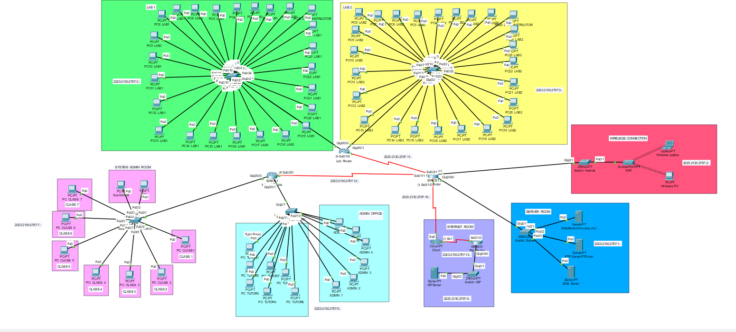
LOGICAL TOPOLOGY
Figure 1- Logical Topology

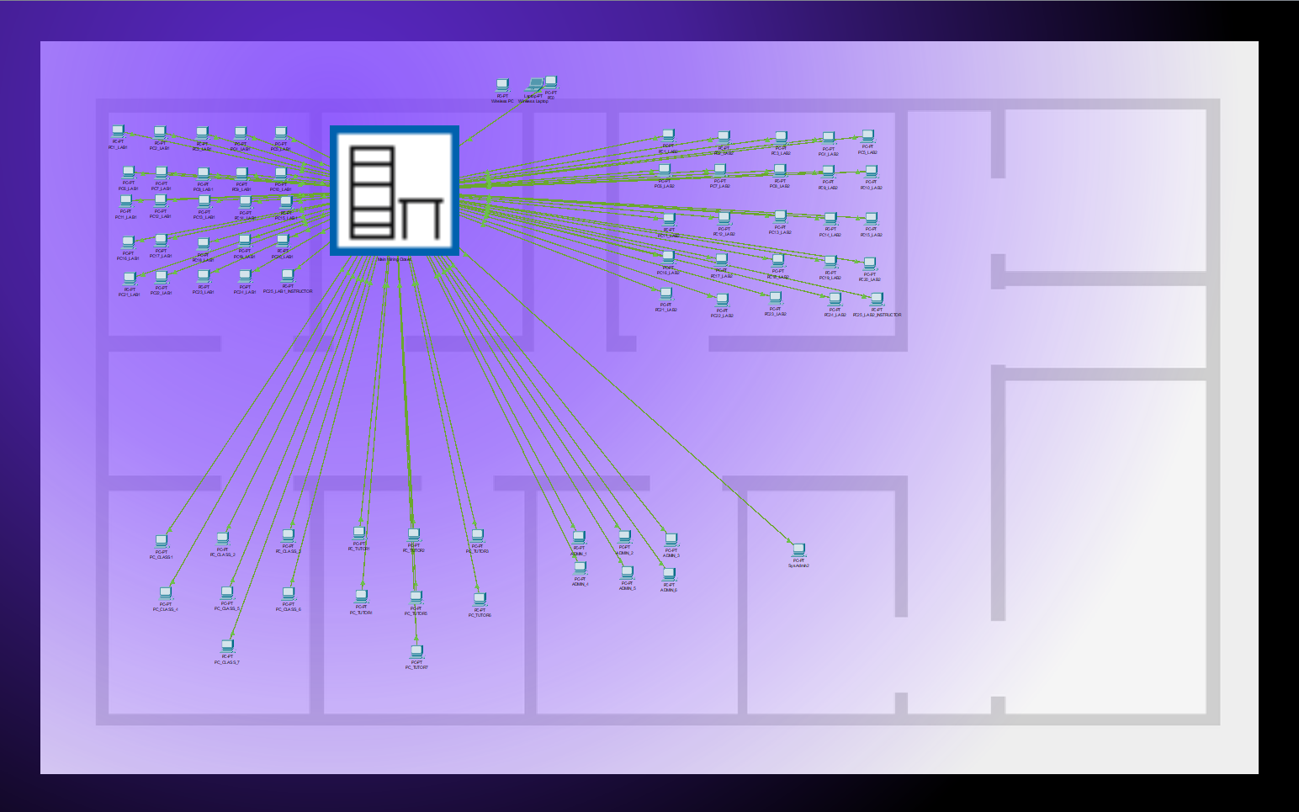
PHYSICAL TOPOLOGY
Figure 2 Physical Topology

LOGICAL DESIGN

ADDRESSING TABLE

LAB 1 IPV6 ADDRESS

PC1_LAB1 | FastEthernet 0 | SWITCH_LAB1  FastEthernet 0/1 | 2023:2130:2787:3:BD15:91E1:835F:835F | FE80::3:1
PC2_LAB1 | FastEthernet 0 | SWITCH_LAB1  FastEthernet 0/2 | 2023:2130:2787:3:9166:7632:68A0:5A1E | FE80::3:1
PC3_LAB1 | FastEthernet 0 | SWITCH_LAB1  FastEthernet 0/3 | 2023:2130:2787:3:878B:79E8:6B56:5DB4 | FE80::3:1
PC4_LAB1 | FastEthernet 0 | SWITCH_LAB1  FastEthernet 0/4 | 2023:2130:2787:3:E03F:D29D:C40B:B669 | FE80::3:1
PC5_LAB1 | FastEthernet 0 | SWITCH_LAB1  FastEthernet 0/5 | 2023:2130:2787:3:998C:8BFA:7D58:6FC5 | FE80::3:1
PC6_LAB1 | FastEthernet 0 | SWITCH_LAB1  FastEthernet 0/6 | 2023:2130:2787:3:F729:A23E:94AC:860A | FE80::3:1
PC7_LAB1 | FastEthernet 0 | SWITCH_LAB1  FastEthernet 0/7 | 2023:2130:2787:3:91FD:6736:5994:4B02 | FE80::3:1
PC8_LAB1 | FastEthernet 0 | SWITCH_LAB1  FastEthernet 0/8 | 2023:2130:2787:3:51CF:35AB:2709:2709 | FE80::3:1
PC9_LAB1 | FastEthernet 0 | SWITCH_LAB1  FastEthernet 0/9 | 2023:2130:2787:3:A87C:9AEA:7FB6:7FB6 | FE80::3:1
PC10_LAB1 | FastEthernet 0 | SWITCH_LAB1  FastEthernet 0/10 | 2023:2130:2787:3:E71D:D97B:BD57:BD57 | FE80::3:1
PC11_LAB1 | FastEthernet 0 | SWITCH_LAB1  FastEthernet 0/11 | 2023:2130:2787:3:5411:38ED:2A5B:2A5B | FE80::3:1
PC12_LAB1 | FastEthernet 0 | SWITCH_LAB1  FastEthernet 0/12 | 2023:2130:2787:3:A699:9807:7DD3:7DD3 | FE80::3:1
PC13_LAB1 | FastEthernet 0 | SWITCH_LAB1  FastEthernet 0/13 | 2023:2130:2787:3:373B:29A9:1B07:E75 | FE80::3:1
PC14_LAB1 | FastEthernet 0 | SWITCH_LAB1  FastEthernet 0/14 | 2023:2130:2787:3:6EFA:42D6:3433:3433 | FE80::3:1
PC15_LAB1 | FastEthernet 0 | SWITCH_LAB1  FastEthernet 0/15 | 2023:2130:2787:3:E442:ACEA:9E58:80B6 | FE80::3:1
PC16_LAB1 | FastEthernet 0 | SWITCH_LAB1  FastEthernet 0/16 | 2023:2130:2787:3:A23D:949B:8609:7966 | FE80::3:1
PC17_LAB1 | FastEthernet 0 | SWITCH_LAB1  FastEthernet 0/17 | 2023:2130:2787:3:68E:EB6A:DDC8:CF36 | FE80::3:1
PC18_LAB1 | FastEthernet 0 | SWITCH_LAB1  FastEthernet 0/18 | 2023:2130:2787:3:EFE9:C3B4:B512:B512 | FE80::3:1
PC19_LAB1 | FastEthernet 0 | SWITCH_LAB1  FastEthernet 0/19 | 2023:2130:2787:3:386D:1C38:EA6:F104 | FE80::3:1
PC20_LAB1 | FastEthernet 0 | SWITCH_LAB1  FastEthernet 0/20 | 2023:2130:2787:3:5B2D:3FF9:2157:13C5 | FE80::3:1
PC21_LAB1 | FastEthernet 0 | SWITCH_LAB1  FastEthernet 0/21 | 2023:2130:2787:3:686:EA52:DCC0:CE2E | FE80::3:1
PC22_LAB1 | FastEthernet 0 | SWITCH_LAB1  FastEthernet 0/22 | 2023:2130:2787:3:E14D:D3AB:C519:B787 | FE80::3:1
PC23_LAB1 | FastEthernet 0 | SWITCH_LAB1  FastEthernet 0/23 | 2023:2130:2787:3:B8A:C332:B590:B590 | FE80::3:1
PC24_LAB1 | FastEthernet 0 | SWITCH_LAB1  FastEthernet 0/24 | 2023:2130:2787:3:89D3:7B31:6DAF:5F0C | FE80::3:1
PC25_LAB1_INSTRUCTOR | FastEthernet 0 | SWITCH_LAB1  GigabitEthernet 0/1 | 2023:2130:2787:3:D6F1:AC3B:8107:8107 | FE80::3:1

LAB 2 IPV6 ADDRESS

PC1_LAB2 | FastEthernet 0 | SWITCH_LAB2  FastEthernet 0/1 | 2023:2130:2787:5:87A3:7901:5DDC:5DDC | FE80::4:1
PC2_LAB2 | FastEthernet 0 | SWITCH_LAB2  FastEthernet 0/2 | 2023:2130:2787:5:F203:D6DF:D6DF:C83D | FE80::4:1
PC3_LAB2 | FastEthernet 0 | SWITCH_LAB2  FastEthernet 0/3 | 2023:2130:2787:5:58CE:1076:2D3:F441 | FE80::4:1
PC4_LAB2 | FastEthernet 0 | SWITCH_LAB2  FastEthernet 0/4 | 2023:2130:2787:5:5548:1DEF:9FDD:813A | FE80::4:1
PC5_LAB2 | FastEthernet 0 | SWITCH_LAB2  FastEthernet 0/5 | 2023:2130:2787:5:65A6:5814:4A71:3CEF | FE80::4:1
PC6_LAB2 | FastEthernet 0 | SWITCH_LAB2  FastEthernet 0/6 | 2023:2130:2787:5:91AF:757B:67E9:5956 | FE80::4:1
PC7_LAB2 | FastEthernet 0 | SWITCH_LAB2  FastEthernet 0/7 | 2023:2130:2787:5:9907:8B65:7ED3:6031 | FE80::4:1
PC8_LAB2 | FastEthernet 0 | SWITCH_LAB2  FastEthernet 0/8 | 2023:2130:2787:5:68A:F8E8:EA55:DCB3 | FE80::4:1
PC9_LAB2 | FastEthernet 0 | SWITCH_LAB2  FastEthernet 0/9 | 2023:2130:2787:5:B530:9A0B:8C69:7ED7 | FE80::4:1
PC10_LAB2 | FastEthernet 0 | SWITCH_LAB2  FastEthernet 0/10 | 2023:2130:2787:5:595C:4BBA:3D27:3D27 | FE80::4:1
PC11_LAB2 | FastEthernet 0 | SWITCH_LAB2  FastEthernet 0/11 | 2023:2130:2787:5:8CA9:52E3:4441:37BF | FE80::4:1
PC12_LAB2 | FastEthernet 0 | SWITCH_LAB2  FastEthernet 0/12 | 2023:2130:2787:5:A603:8AEE:7C4C:7C4C | FE80::4:1
PC13_LAB2 | FastEthernet 0 | SWITCH_LAB2  FastEthernet 0/13 | 2023:2130:2787:5:5050:42CE:342C:2699 | FE80::4:1
PC14_LAB2 | FastEthernet 0 | SWITCH_LAB2  FastEthernet 0/14 | 2023:2130:2787:5:CF76:A342:95B0:95B0 | FE80::4:1
PC15_LAB2 | FastEthernet 0 | SWITCH_LAB2  FastEthernet 0/15 | 2023:2130:2787:5:9341:5BF8:4D56:3FC4 | FE80::4:1
PC16_LAB2 | FastEthernet 0 | SWITCH_LAB2  FastEthernet 0/16 | 2023:2130:2787:5:F610:DAEC:DAEC:CC5A | FE80::4:1
PC17_LAB2 | FastEthernet 0 | SWITCH_LAB2  FastEthernet 0/17 | 2023:2130:2787:5:EE61:D0DE:C33C:C33C | FE80::4:1
PC18_LAB2 | FastEthernet 0 | SWITCH_LAB2  FastEthernet 0/18 | 2023:2130:2787:5:77E3:6951:5BBF:4D2C | FE80::4:1
PC19_LAB2 | FastEthernet 0 | SWITCH_LAB2  FastEthernet 0/19 | 2023:2130:2787:5:A616:9874:8AE2:7C50 | FE80::4:1
PC20_LAB2 | FastEthernet 0 | SWITCH_LAB2  FastEthernet 0/20 | 2023:2130:2787:5:6F8:EAC4:CEAF:CEAF | FE80::4:1
PC21_LAB2 | FastEthernet 0 | SWITCH_LAB2  FastEthernet 0/21 | 2023:2130:2787:5:C61D:AAE8:9C56:8EC4 | FE80::4:1
PC22_LAB2 | FastEthernet 0 | SWITCH_LAB2  FastEthernet 0/22 | 2023:2130:2787:5:624B:4617:3885:3885 | FE80::4:1
PC23_LAB2 | FastEthernet 0 | SWITCH_LAB2  FastEthernet 0/23 | 2023:2130:2787:5:9901:8B7F:7DDD:7DDD | FE80::4:1
PC24_LAB2 | FastEthernet 0 | SWITCH_LAB2  FastEthernet 0/24 | 2023:2130:2787:5:E0F7:D265:C4D3:B631 | FE80::4:1
PC25_LAB2_INSTRUCTOR | FastEthernet 0 | SWITCH_LAB2  GigabitEthernet 0/1 | 2023:2130:2787:5:128F:DA27:CC95:BEF2 | FE80::4:1

TUTOR ROOM IPV6 ADDRESS

PC_TUTOR1 | FastEthernet 0 | SWITCH_TUTOR_ADMIN  FastEthernet 0/1 | 2023:2130:2787:8:3FC9:6F2:EADE:EADE | FE80::9:1
PC_TUTOR2 | FastEthernet 0 | SWITCH_TUTOR_ADMIN  FastEthernet 0/2 | 2023:2130:2787:8:188D:AEB:FC59:EEC7 | FE80::9:1
PC_TUTOR3 | FastEthernet 0 | SWITCH_TUTOR_ADMIN  FastEthernet 0/3 | 2023:2130:2787:8:2F2D:E8C4:DA32:CC90 | FE80::9:1
PC_TUTOR4 | FastEthernet 0 | SWITCH_TUTOR_ADMIN  FastEthernet 0/4 | 2023:2130:2787:8:D60C:BAE8:AC46:9EB4 | FE80::9:1
PC_TUTOR5 | FastEthernet 0 | SWITCH_TUTOR_ADMIN  FastEthernet 0/5 | 2023:2130:2787:8:329F:166B:8D9:FA37 | FE80::9:1
PC_TUTOR6 | FastEthernet 0 | SWITCH_TUTOR_ADMIN  FastEthernet 0/6 | 2023:2130:2787:8:A78:FCD6:EE44:D0B2 | FE80::9:1
PC_TUTOR7 | FastEthernet 0 | SWITCH_TUTOR_ADMIN  FastEthernet 0/7 | 2023:2130:2787:8:470:F6DE:E84C:DAA9 | FE80::9:1
ADMIN OFFICE IPV6 ADDRESS

ADMIN_1 | FastEthernet 0 | SWITCH_TUTOR_ADMIN  FastEthernet 0/8 | 2023:2130:2787:5:68A:F8E8:EA55:DCB3 | FE80::4:1
ADMIN_2 | FastEthernet 0 | SWITCH_TUTOR_ADMIN  FastEthernet 0/9 | 2023:2130:2787:5:B530:9A0B:8C69:7ED7 | FE80::4:1
ADMIN_3 | FastEthernet 0 | SWITCH_TUTOR_ADMIN  FastEthernet 0/10 | 2023:2130:2787:5:595C:4BBA:3D27:3D27 | FE80::4:1
ADMIN_4 | FastEthernet 0 | SWITCH_TUTOR_ADMIN  FastEthernet 0/11 | 2023:2130:2787:5:8CA9:52E3:4441:37BF | FE80::4:1
ADMIN_5 | FastEthernet 0 | SWITCH_TUTOR_ADMIN  FastEthernet 0/12 | 2023:2130:2787:5:A603:8AEE:7C4C:7C4C | FE80::4:1
ADMIN_6 | FastEthernet 0 | SWITCH_TUTOR_ADMIN  FastEthernet 0/13 | 2023:2130:2787:5:5050:42CE:342C:2699 | FE80::4:1
ADMIN_7 | FastEthernet 0 | SWITCH_TUTOR_ADMIN  FastEthernet 0/14 | 2023:2130:2787:5:CF76:A342:95B0:95B0 | FE80::4:1

SYSTEM ADMIN ROOM IPV6 ADDRESS

SYSADMIN1 | FastEthernet 0 | SWITCH_CLASS_SYSADMIN  FastEthernet 0/1 | 2023:2130:2787:7:FA60:DE3C:C0AA:C0AA | FE80::8:1
SYSADMIN2 | FastEthernet 0 | SWITCH_CLASS_SYSADMIN  FastEthernet 0/2 | 2023:2130:2787:7:BF38:A1A6:9314:8572 | FE80::8:1
CLASS IPV6 ADDRESS

CLASS_1 | FastEthernet 0 | SWITCH_CLASS_SYSADMIN  FastEthernet 0/9 | 2023:2130:2787:7:1F5B:F327:E594:E594 | FE80::8:1
CLASS_2 | FastEthernet 0 | SWITCH_CLASS_SYSADMIN  FastEthernet 0/8 | 2023:2130:2787:7:3588:1954:BC2:FD20 | FE80::8:1
CLASS_3 | FastEthernet 0 | SWITCH_CLASS_SYSADMIN  FastEthernet 0/7 | 2023:2130:2787:7:6077:53D5:4542:4542 | FE80::8:1
CLASS_4 | FastEthernet 0 | SWITCH_CLASS_SYSADMIN  FastEthernet 0/6 | 2023:2130:2787:7:5101:437E:35EC:274A | FE80::8:1
CLASS_5 | FastEthernet 0 | SWITCH_CLASS_SYSADMIN  FastEthernet 0/5 | 2023:2130:2787:7:472D:2BF9:C86C:BADA | FE80::8:1
CLASS_6 | FastEthernet 0 | SWITCH_CLASS_SYSADMIN  FastEthernet 0/4 | 2023:2130:2787:7:60C7:44A3:3701:3701 | FE80::8:1
CLASS_7 | FastEthernet 0 | SWITCH_CLASS_SYSADMIN  FastEthernet 0/3 | 2023:2130:2787:7:CD55:939F:776B:776B | FE80::8:1
WIRELESS IPV6 ADDRESS

WIRELESS PC | Wireless | SWITCH_INTERNET  FastEthernet 0/1 | 2023:2130:2787:2:D40B:B9E6:AB44:9DB2 | FE80::2:1
WIRELESS LAPTOP | Wireless | SWITCH_INTERNET  FastEthernet 0/2 | 2023:2130:2787:2:89AE:4245:2621:2621 | FE80::2:1

DEVICE | CONNECTED FROM | CONNECTED TO | IP ADDRESS | LINK-LOCAL
MAIN_ROUTER | GigabitEthernet 0/0/0 | Switch_Server  GigabitEthernet 0/2 | 2023:2130:2787:1::1 | FE80::1:1
MAIN_ROUTER | GigabitEthernet 0/0/1 | Switch_Internet  GigabitEthernet 0/1 | 2023:2130:2787:2::1 | FE80::2:1
MAIN_ROUTER | Serial 0/1/0 | Cloud-PT Cloud  Serial 0 | 2023:2130:2787:10::1 | FE80::5:1
MAIN_ROUTER | Serial 0/1/1 | Internal_Router  Serial 0/2/0 | 2023:2130:2787:11::1 | FE80::5:2
MAIN_ROUTER | Serial 0/2/1 | Lab_Router  Serial 0/1/0 | 2023:2130:2787:12::1 | FE80::5:3
LAB_ROUTER | GigabitEthernet 0/0/0 | Switch_LAB1  GigabitEthernet 0/2 | 2023:2130:2787:3::1 | FE80::3:1
LAB_ROUTER | GigabitEthernet 0/0/1 | Switch_LAB2  GigabitEthernet 0/2 | 2023:2130:2787:5::1 | FE80::4:1
LAB_ROUTER | Serial0/1/0 | Main_Router  Serial 0/2/0 | 2023:2130:2787:11::2 | FE80::5:4
INTERNAL_ROUTER | GigabitEthernet 0/0/0 | Switch_Class_Sysadmin  GigabitEthernet 0/1 | 2023:2130:2787:7::1 | FE80::8:1
INTERNAL_ROUTER | GigabitEthernet 0/0/1 | Tutor_Admin_Switch  GigabitEthernet 0/1 | 2023:2130:2787:8::1 | FE80::9:1
INTERNAL_ROUTER | Serial0/2/0 | Main_Router  Serial 0/1/1 | 2023:2130:2787:12::2 | FE80::5:6
TM_ROUTER | GigabitEthernet 0/0/0 | Switch_ISP  GigabitEthernet 0/1 | 2023:2130:2787:9::1 | FE80::10:1
TM_ROUTER | Serial 0/1/0 | Cloud-PT Cloud  Serial 1 | 2023:2130:2787:13::1 | FE80::5:7
FTP_SERVER | FastEthernet 0 | Switch_Server  FastEthernet 0/1 | 2023:2130:2787:1::5 | 2023:2130:2787:1::1
WEB_SERVER | FastEthernet 0 | Switch_Server  FastEthernet 0/2 | 2023:2130:2787:1::4 | 2023:2130:2787:1::1
DNS_SERVER | FastEthernet 0 | Switch_Server  FastEthernet 0/3 | 2023:2130:2787:1::300 | 2023:2130:2787:1::1
ISP_SERVER | FastEthernet 0 | Switch_Server  GigabitEthernet 0/2 | 2023:2130:2787:9::5 | 2023:2130:2787:9::1

ROUTER CONFIGURATION

Main Router

Router>enable
Router#configure terminal
Router(config)#hostname Main_Router

Main_Router(config)#ipv6 unicast-routing
Main_Router(config)#ipv6 dhcp pool STATEFUL_1
Main_Router(config-dhcpv6)#address prefix 2023:2130:2787:1::/64
Main_Router(config-dhcpv6)#dns-server 2023:2130:2787:1::300
Main_Router(config-dhcpv6)#domain-name Main_server.com
Main_Router(config-dhcpv6)#exit

Main_Router(config)#ipv6 dhcp pool STATEFUL_2
Main_Router(config-dhcpv6)#address prefix 2023:2130:2787:2::/64
Main_Router(config-dhcpv6)#dns-server 2023:2130:2787:1::300
Main_Router(config-dhcpv6)#domain-name Main_wifi.com
Main_Router(config-dhcpv6)#exit

Main_Router(config)#ipv6 router ospf 10
Main_Router(config-rtr)#router-id 1.1.1.1
Main_Router(config-rtr)#exit

Main_Router(config)#interface GigabitEthernet 0/0/0
Main_Router(config-if)#ipv6 address 2023:2130:2787:1::1/64
Main_Router(config-if)#ipv6 address FE80::1:1 link-local
Main_Router(config-if)#ipv6 nd managed-config-flag
Main_Router(config-if)#ipv6 dhcp server STATEFUL_1
Main_Router(config-if)#ipv6 ospf 10 area 0
Main_Router(config-if)#no shutdown
Main_Router(config-if)#exit

Main_Router(config)#interface GigabitEthernet 0/0/1
Main_Router(config-if)#ipv6 address 2023:2130:2787:2::1/64
Main_Router(config-if)#ipv6 address FE80::2:1 link-local
Main_Router(config-if)#ipv6 nd managed-config-flag
Main_Router(config-if)#ipv6 dhcp server STATEFUL_2
Main_Router(config-if)#ipv6 ospf 10 area 0
Main_Router(config-if)#no shutdown
Main_Router(config-if)#exit

Main_Router(config)#interface Serial 0/1/0
Main_Router(config-if)#ipv6 address 2023:2130:2787:10::1/64
Main_Router(config-if)#ipv6 address FE80::5:1 link-local
Main_Router(config-if)#ipv6 enable
Main_Router(config-if)#ipv6 ospf 10 area 0
Main_Router(config-if)#no shutdown
Main_Router(config-if)#exit

Main_Router(config)#interface serial 0/1/1
Main_Router(config-if)#ipv6 address 2023:2130:2787:11::1/64
Main_Router(config-if)#ipv6 address FE80::5:2 link-local
Main_Router(config-if)#ipv6 enable
Main_Router(config-if)#ipv6 ospf 10 area 0
Main_Router(config-if)#no shutdown
Main_Router(config-if)#exit
Main_Router(config)#interface Serial 0/2/1
Main_Router(config-if)#ipv6 address 2023:2130:2787:12::1/64
Main_Router(config-if)#ipv6 address FE80::5:3 link-local
Main_Router(config-if)#ipv6 enable
Main_Router(config-if)#ipv6 ospf 10 area 0
Main_Router(config-if)#no shutdown
Main_Router(config-if)#end

Main_Router#copy run start

Lab_Router
Router>enable
Router#configure terminal
Router(config)#hostname Lab_Router

Lab_Router(config)#ipv6 unicast-routing
Lab_Router(config)#ipv6 dhcp pool STATEFUL_3
Lab_Router(config-dhcpv6)#address prefix 2023:2130:2787:3::/64
Lab_Router(config-dhcpv6)#dns-server 2023:2130:2787:1::300
Lab_Router(config-dhcpv6)#domain-name Lab_1.com
Lab_Router(config-dhcpv6)#exit

Lab_Router(config)#ipv6 dhcp pool STATEFUL_4
Lab_Router(config-dhcpv6)#address prefix 2023:2130:2787:5::/64
Lab_Router(config-dhcpv6)#dns-server 2023:2130:2787:1::300
Lab_Router(config-dhcpv6)#domain-name Lab_2.com
Lab_Router(config-dhcpv6)#exit

Lab_Router(config)#ipv6 router ospf 10
Lab_Router(config-rtr)#router-id 2.2.2.2
Lab_Router(config-rtr)#exit

Lab_Router(config)#interface GigabitEthernet 0/0/0
Lab_Router(config-if)#ipv6 address 2023:2130:2787:3::1/64
Lab_Router(config-if)#ipv6 address FE80::3:1 link-local
Lab_Router(config-if)#ipv6 nd managed-config-flag
Lab_Router(config-if)#ipv6 dhcp server STATEFUL_3
Lab_Router(config-if)#ipv6 ospf 10 area 0
Lab_Router(config-if)#no shutdown
Lab_Router(config-if)#exit

Lab_Router(config-if)#interface GigabitEthernet 0/0/1
Lab_Router(config-if)#ipv6 address 2023:2130:2787:5::1/64
Lab_Router(config-if)#ipv6 address FE80::4:1 link-local
Lab_Router(config-if)#ipv6 nd managed-config-flag
Lab_Router(config-if)#ipv6 dhcp server STATEFUL_4
Lab_Router(config-if)#ipv6 ospf 10 area 0
Lab_Router(config-if)#no shutdown
Lab_Router(config-if)#exit

Lab_Router(config)#interface Serial 0/1/0
Lab_Router(config-if)#ipv6 address 2023:2130:2787:11::2/64
Lab_Router(config-if)#ipv6 address FE80::5:4 link-local
Lab_Router(config-if)#ipv6 enable
Lab_Router(config-if)#ipv6 ospf 10 area 0
Lab_Router(config-if)#no shutdown
Lab_Router(config-if)#end

Lab_Router#copy run start

Internal_Router
Router>enable
Router#configure terminal
Router(config)#hostname Internal_Router

Internal_Router(config)#ipv6 unicast-routing
Internal_Router(config)#ipv6 dhcp pool STATEFUL_5
Internal_Router(config-dhcpv6)#address prefix 2023:2130:2787:7::/64
Internal_Router(config-dhcpv6)#dns-server 2023:2130:2787:1::300
Internal_Router(config-dhcpv6)#domain-name Clasroom.com
Internal_Router(config-dhcpv6)#exit

Internal_Router(config)#ipv6 dhcp pool STATEFUL_6
Internal_Router(config-dhcpv6)#address prefix 2023:2130:2787:8::/64
Internal_Router(config-dhcpv6)#dns-server 2023:2130:2787:1::300
Internal_Router(config-dhcpv6)#domain-name Tutor_admin.com
Internal_Router(config-dhcpv6)#exit

Internal_Router(config)#ipv6 router ospf 10
Internal_Router(config-rtr)#router-id 3.3.3.3
Internal_Router(config-rtr)#exit

Internal_Router(config)#interface GigabitEthernet 0/0/0
Internal_Router(config-if)#ipv6 address 2023:2130:2787:7::1/64
Internal_Router(config-if)#ipv6 address FE80::8:1 link-local
Internal_Router(config-if)#ipv6 nd managed-config-flag
Internal_Router(config-if)#ipv6 dhcp server STATEFUL_5
Internal_Router(config-if)#ipv6 ospf 10 area 0
Internal_Router(config-if)#no shutdown
Internal_Router(config-if)#exit

Internal_Router(config)#interface GigabitEthernet 0/0/1
Internal_Router(config-if)#ipv6 address 2023:2130:2787:8::1/64
Internal_Router(config-if)#ipv6 address FE80::9:1 link-local
Internal_Router(config-if)#ipv6 nd managed-config-flag
Internal_Router(config-if)#ipv6 dhcp server STATEFUL_6
Internal_Router(config-if)#ipv6 ospf 10 area 0
Internal_Router(config-if)#no shutdown
Internal_Router(config-if)#exit

Internal_Router(config)#interface GigabitEthernet 0/0/0
Internal_Router(config-if)#ipv6 address 2023:2130:2787:7::1/64
Internal_Router(config-if)#ipv6 address FE80::8:1 link-local
Internal_Router(config-if)#ipv6 nd managed-config-flag
Internal_Router(config-if)#ipv6 dhcp server STATEFUL_5
Internal_Router(config-if)#ipv6 ospf 10 area 0
Internal_Router(config-if)#no shutdown
Internal_Router(config-if)#exit

Internal_Router(config)#interface Serial 0/2/0
Internal_Router(config-if)#ipv6 address 2023:2130:2787:12::2/64
Internal_Router(config-if)#ipv6 address FE80::5:6 link-local
Internal_Router(config-if)#ipv6 enable
Internal_Router(config-if)#ipv6 ospf 10 area 0
Internal_Router(config-if)#no shutdown
Internal_Router(config-if)#end

Internal_Router#copy run start
TM router
Router>enable
Router#configure terminal
Router(config)#hostname TM_Router

TM_Router(config)#ipv6 unicast-routing
TM_Router(config)#ipv6 dhcp pool STATEFUL_7
TM_Router(config-dhcpv6)#address prefix 2023:2130:2787:9::/64
TM_Router(config-dhcpv6)#dns-server 2023:2130:2787:1::300
TM_Router(config-dhcpv6)#domain-name TM_Server.com
TM_Router(config-dhcpv6)#exit

TM_Router(config)#ipv6 router ospf 10
TM_Router(config-rtr)#router-id 4.4.4.4
TM_Router(config-rtr)#exit

TM_Router(config)#interface GigabitEthernet 0/0/0
TM_Router(config-if)#ipv6 address 2023:2130:2787:9::1/64
TM_Router(config-if)#ipv6 address FE80::10:1 link-local
TM_Router(config-if)#ipv6 nd managed-config-flag
TM_Router(config-if)#ipv6 dhcp server STATEFUL_7
TM_Router(config-if)#ipv6 ospf 10 area 0
TM_Router(config-if)#no shutdown
TM_Router(config-if)#exit

TM_Router(config)#interface Serial 0/1/0
TM_Router(config-if)#ipv6 address 2023:2130:2787:13::1/64
TM_Router(config-if)#ipv6 address FE80::5:7 link-local
TM_Router(config-if)#ipv6 enable
TM_Router(config-if)#ipv6 ospf 10 area 0
TM_Router(config-if)#no shutdown
TM_Router(config-if)#end
TM_Router#copy run start

IPV6 ROUTER CONFIGURATION
Main Router
Main_Router#show ipv6 route
IPv6 Routing Table - 19 entries
Codes: C - Connected, L - Local, S - Static, R - RIP, B - BGP
U - Per-user Static route, M - MIPv6
I1 - ISIS L1, I2 - ISIS L2, IA - ISIS interarea, IS - ISIS summary
ND - ND Default, NDp - ND Prefix, DCE - Destination, NDr - Redirect
O - OSPF intra, OI - OSPF inter, OE1 - OSPF ext 1, OE2 - OSPF ext 2
ON1 - OSPF NSSA ext 1, ON2 - OSPF NSSA ext 2
D - EIGRP, EX - EIGRP external
O 2023:1110:319:1::/64 [110/65]
via FE80::5:6, Serial0/2/1
O 2023:1110:319:2::/64 [110/65]
via FE80::5:6, Serial0/2/1
C 2023:2130:2787:1::/64 [0/0]
via GigabitEthernet0/0/0, directly connected
L 2023:2130:2787:1::1/128 [0/0]
via GigabitEthernet0/0/0, receive
C 2023:2130:2787:2::/64 [0/0]
via GigabitEthernet0/0/1, directly connected
L 2023:2130:2787:2::1/128 [0/0]
via GigabitEthernet0/0/1, receive
O 2023:2130:2787:3::/64 [110/65]
via FE80::5:4, Serial0/1/1
O 2023:2130:2787:5::/64 [110/65]
via FE80::5:4, Serial0/1/1
O 2023:2130:2787:7::/64 [110/65]
via FE80::5:6, Serial0/2/1
O 2023:2130:2787:8::/64 [110/65]
via FE80::5:6, Serial0/2/1
O 2023:2130:2787:9::/64 [110/65]
via FE80::5:7, Serial0/1/0
C 2023:2130:2787:10::/64 [0/0]
via Serial0/1/0, directly connected
L 2023:2130:2787:10::1/128 [0/0]
via Serial0/1/0, receive
C 2023:2130:2787:11::/64 [0/0]
via Serial0/1/1, directly connected
L 2023:2130:2787:11::1/128 [0/0]
via Serial0/1/1, receive
C 2023:2130:2787:12::/64 [0/0]
via Serial0/2/1, directly connected
L 2023:2130:2787:12::1/128 [0/0]
via Serial0/2/1, receive
O 2023:2130:2787:13::/64 [110/64]
via
L FF00::/8 [0/0]
via Null0, receive
Lab Router
Lab_Router#show ipv6 route
IPv6 Routing Table - 17 entries
Codes: C - Connected, L - Local, S - Static, R - RIP, B - BGP
U - Per-user Static route, M - MIPv6
I1 - ISIS L1, I2 - ISIS L2, IA - ISIS interarea, IS - ISIS summary
ND - ND Default, NDp - ND Prefix, DCE - Destination, NDr - Redirect
O - OSPF intra, OI - OSPF inter, OE1 - OSPF ext 1, OE2 - OSPF ext 2
ON1 - OSPF NSSA ext 1, ON2 - OSPF NSSA ext 2
D - EIGRP, EX - EIGRP external
O 2023:1110:319:1::/64 [110/129]
via FE80::5:2, Serial0/1/0
O 2023:1110:319:2::/64 [110/129]
via FE80::5:2, Serial0/1/0
O 2023:2130:2787:1::/64 [110/65]
via FE80::5:2, Serial0/1/0
O 2023:2130:2787:2::/64 [110/65]
via FE80::5:2, Serial0/1/0
C 2023:2130:2787:3::/64 [0/0]
via GigabitEthernet0/0/0, directly connected
L 2023:2130:2787:3::1/128 [0/0]
via GigabitEthernet0/0/0, receive
C 2023:2130:2787:5::/64 [0/0]
via GigabitEthernet0/0/1, directly connected
L 2023:2130:2787:5::1/128 [0/0]
via GigabitEthernet0/0/1, receive
O 2023:2130:2787:7::/64 [110/129]
via FE80::5:2, Serial0/1/0
O 2023:2130:2787:8::/64 [110/129]
via FE80::5:2, Serial0/1/0
O 2023:2130:2787:9::/64 [110/129]
via FE80::5:2, Serial0/1/0
O 2023:2130:2787:10::/64 [110/128]
via FE80::5:2, Serial0/1/0
C 2023:2130:2787:11::/64 [0/0]
via Serial0/1/0, directly connected
L 2023:2130:2787:11::2/128 [0/0]
via Serial0/1/0, receive
O 2023:2130:2787:12::/64 [110/128]
via FE80::5:2, Serial0/1/0
O 2023:2130:2787:13::/64 [110/128]
via FE80::5:2, Serial0/1/0
L FF00::/8 [0/0]
via Null0, receive
Internal Router
Internal_Router#show ipv6 route
IPv6 Routing Table - 19 entries
Codes: C - Connected, L - Local, S - Static, R - RIP, B - BGP
U - Per-user Static route, M - MIPv6
I1 - ISIS L1, I2 - ISIS L2, IA - ISIS interarea, IS - ISIS summary
ND - ND Default, NDp - ND Prefix, DCE - Destination, NDr - Redirect
O - OSPF intra, OI - OSPF inter, OE1 - OSPF ext 1, OE2 - OSPF ext 2
ON1 - OSPF NSSA ext 1, ON2 - OSPF NSSA ext 2
D - EIGRP, EX - EIGRP external
C 2023:1110:319:1::/64 [0/0]
via GigabitEthernet0/0/0, directly connected
L 2023:1110:319:1::1/128 [0/0]
via GigabitEthernet0/0/0, receive
C 2023:1110:319:2::/64 [0/0]
via GigabitEthernet0/0/1, directly connected
L 2023:1110:319:2::1/128 [0/0]
via GigabitEthernet0/0/1, receive
O 2023:2130:2787:1::/64 [110/65]
via FE80::5:3, Serial0/2/0
O 2023:2130:2787:2::/64 [110/65]
via FE80::5:3, Serial0/2/0
O 2023:2130:2787:3::/64 [110/129]
via FE80::5:3, Serial0/2/0
O 2023:2130:2787:5::/64 [110/129]
via FE80::5:3, Serial0/2/0
C 2023:2130:2787:7::/64 [0/0]
via GigabitEthernet0/0/0, directly connected
L 2023:2130:2787:7::1/128 [0/0]
via GigabitEthernet0/0/0, receive
C 2023:2130:2787:8::/64 [0/0]
via GigabitEthernet0/0/1, directly connected
L 2023:2130:2787:8::1/128 [0/0]
via GigabitEthernet0/0/1, receive
O 2023:2130:2787:9::/64 [110/129]
via FE80::5:3, Serial0/2/0
O 2023:2130:2787:10::/64 [110/128]
via FE80::5:3, Serial0/2/0
O 2023:2130:2787:11::/64 [110/128]
via FE80::5:3, Serial0/2/0
C 2023:2130:2787:12::/64 [0/0]
via Serial0/2/0, directly connected
L 2023:2130:2787:12::2/128 [0/0]
via Serial0/2/0, receive
O 2023:2130:2787:13::/64 [110/128]
via FE80::5:3, Serial0/2/0
L FF00::/8 [0/0]
via Null0, receive
TM Router
TM_Router#show ipv6 route
IPv6 Routing Table - 16 entries
Codes: C - Connected, L - Local, S - Static, R - RIP, B - BGP
U - Per-user Static route, M - MIPv6
I1 - ISIS L1, I2 - ISIS L2, IA - ISIS interarea, IS - ISIS summary
ND - ND Default, NDp - ND Prefix, DCE - Destination, NDr - Redirect
O - OSPF intra, OI - OSPF inter, OE1 - OSPF ext 1, OE2 - OSPF ext 2
ON1 - OSPF NSSA ext 1, ON2 - OSPF NSSA ext 2
D - EIGRP, EX - EIGRP external
O 2023:1110:319:1::/64 [110/129]
via FE80::5:1, Serial0/1/0
O 2023:1110:319:2::/64 [110/129]
via FE80::5:1, Serial0/1/0
O 2023:2130:2787:1::/64 [110/65]
via FE80::5:1, Serial0/1/0
O 2023:2130:2787:2::/64 [110/65]
via FE80::5:1, Serial0/1/0
O 2023:2130:2787:3::/64 [110/129]
via FE80::5:1, Serial0/1/0
O 2023:2130:2787:5::/64 [110/129]
via FE80::5:1, Serial0/1/0
O 2023:2130:2787:7::/64 [110/129]
via FE80::5:1, Serial0/1/0
O 2023:2130:2787:8::/64 [110/129]
via FE80::5:1, Serial0/1/0
C 2023:2130:2787:9::/64 [0/0]
via GigabitEthernet0/0/0, directly connected
L 2023:2130:2787:9::1/128 [0/0]
via GigabitEthernet0/0/0, receive
O 2023:2130:2787:10::/64 [110/64]
via
O 2023:2130:2787:11::/64 [110/128]
via FE80::5:1, Serial0/1/0
O 2023:2130:2787:12::/64 [110/128]
via FE80::5:1, Serial0/1/0
C 2023:2130:2787:13::/64 [0/0]
via Serial0/1/0, directly connected
L 2023:2130:2787:13::1/128 [0/0]
via Serial0/1/0, receive
L FF00::/8 [0/0]
via Null0, receive

DHCP SERVER CONFIGURATION
Main_Router
Main_Router>enable
Main_Router#configure terminal
Main_Router(config)#ipv6 unicast-routing
Main_Router(config)#ipv6 dhcp pool STATEFUL_1
Main_Router(config-dhcpv6)#address prefix 2023:2130:2787:1::/64
Main_Router(config-dhcpv6)#dns-server 2023:2130:2787:1::300
Main_Router(config-dhcpv6)#domain-name Main_server.com
Main_Router(config-dhcpv6)#exit

Main_Router(config)#ipv6 dhcp pool STATEFUL_2
Main_Router(config-dhcpv6)#address prefix 2023:2130:2787:2::/64
Main_Router(config-dhcpv6)#dns-server 2023:2130:2787:1::300
Main_Router(config-dhcpv6)#domain-name Main_wifi.com
Main_Router(config-dhcpv6)#exit

Main_Router(config)#interface GigabitEthernet 0/0/0
Main_Router(config-if)#ipv6 nd managed-config-flag
Main_Router(config-if)#ipv6 dhcp server STATEFUL_1
Main_Router(config-if)#no shutdown
Main_Router(config-if)#exit

Main_Router(config)#interface GigabitEthernet 0/0/1
Main_Router(config-if)#ipv6 nd managed-config-flag
Main_Router(config-if)#ipv6 dhcp server STATEFUL_2
Main_Router(config-if)#no shutdown
Main_Router(config-if)#exit

Lab_Router
Lab_Router>enable
Lab_Router#configure terminal
Lab_Router(config)#ipv6 unicast-routing
Lab_Router(config)#ipv6 dhcp pool STATEFUL_3
Lab_Router(config-dhcpv6)#address prefix 2023:2130:2787:3::/64
Lab_Router(config-dhcpv6)#dns-server 2023:2130:2787:1::300
Lab_Router(config-dhcpv6)#domain-name Lab_1.com
Lab_Router(config-dhcpv6)#exit

Lab_Router(config)#ipv6 dhcp pool STATEFUL_4
Lab_Router(config-dhcpv6)#address prefix 2023:2130:2787:5::/64
Lab_Router(config-dhcpv6)#dns-server 2023:2130:2787:1::300
Lab_Router(config-dhcpv6)#domain-name Lab_2.com
Lab_Router(config-dhcpv6)#exit

Lab_Router(config)#interface GigabitEthernet 0/0/0
Lab_Router(config-if)#ipv6 nd managed-config-flag
Lab_Router(config-if)#ipv6 dhcp server STATEFUL_3
Lab_Router(config-if)#no shutdown
Lab_Router(config-if)#exit

Lab_Router(config-if)#interface GigabitEthernet 0/0/1
Lab_Router(config-if)#ipv6 nd managed-config-flag
Lab_Router(config-if)#ipv6 dhcp server STATEFUL_4
Lab_Router(config-if)#no shutdown
Lab_Router(config-if)#exit

Internal_Router
Internal_Router>enable
Internal_Router#configure terminal
Internal_Router(config)#ipv6 unicast-routing
Internal_Router(config)#ipv6 dhcp pool STATEFUL_5
Internal_Router(config-dhcpv6)#address prefix 2023:2130:2787:7::/64
Internal_Router(config-dhcpv6)#dns-server 2023:2130:2787:1::300
Internal_Router(config-dhcpv6)#domain-name Clasroom.com
Internal_Router(config-dhcpv6)#exit

Internal_Router(config)#ipv6 dhcp pool STATEFUL_6
Internal_Router(config-dhcpv6)#address prefix 2023:2130:2787:8::/64
Internal_Router(config-dhcpv6)#dns-server 2023:2130:2787:1::300
Internal_Router(config-dhcpv6)#domain-name Tutor_admin.com
Internal_Router(config-dhcpv6)#exit

Internal_Router(config)#interface GigabitEthernet 0/0/0
Internal_Router(config-if)#ipv6 nd managed-config-flag
Internal_Router(config-if)#ipv6 dhcp server STATEFUL_5
Internal_Router(config-if)#no shutdown
Internal_Router(config-if)#exit

Internal_Router(config)#interface GigabitEthernet 0/0/1
Internal_Router(config-if)#ipv6 nd managed-config-flag
Internal_Router(config-if)#ipv6 dhcp server STATEFUL_6
Internal_Router(config-if)#no shutdown
Internal_Router(config-if)#exit

TM Router
TM_Router>enable
TM_Router#configure terminal
TM_Router(config)#ipv6 unicast-routing
TM_Router(config)#ipv6 dhcp pool STATEFUL_7
TM_Router(config-dhcpv6)#address prefix 2023:2130:2787:9::/64
TM_Router(config-dhcpv6)#dns-server 2023:2130:2787:1::300
TM_Router(config-dhcpv6)#domain-name TM_Server.com
TM_Router(config-dhcpv6)#exit

TM_Router(config)#interface GigabitEthernet 0/0/0
TM_Router(config-if)#ipv6 nd managed-config-flag
TM_Router(config-if)#ipv6 dhcp server STATEFUL_7
TM_Router(config-if)#no shutdown
TM_Router(config-if)#exit

OSPF CONFIGURATION
Main Router
Main_Router>enable
Main_Router#configure terminal
Main_Router(config)#ipv6 router ospf 10
Main_Router(config-rtr)#router-id 1.1.1.1
Main_Router(config-rtr)#exit

Main_Router(config)#interface GigabitEthernet 0/0/0
Main_Router(config-if)#ipv6 ospf 10 area 0
Main_Router(config-if)#no shutdown
Main_Router(config-if)#exit

Main_Router(config)#interface GigabitEthernet 0/0/1
Main_Router(config-if)#ipv6 ospf 10 area 0
Main_Router(config-if)#no shutdown
Main_Router(config-if)#exit

Main_Router(config)#interface Serial 0/1/0
Main_Router(config-if)#ipv6 ospf 10 area 0
Main_Router(config-if)#no shutdown
Main_Router(config-if)#exit

Main_Router(config)#interface serial 0/1/1
Main_Router(config-if)#ipv6 ospf 10 area 0
Main_Router(config-if)#no shutdown
Main_Router(config-if)#exit

Main_Router(config)#interface Serial 0/2/1
Main_Router(config-if)#ipv6 ospf 10 area 0
Main_Router(config-if)#no shutdown
Main_Router(config-if)#exit

Lab Router
Lab_Router>enable
Lab_Router#configure terminal
Lab_Router(config)#ipv6 router ospf 10
Lab_Router(config-rtr)#router-id 2.2.2.2
Lab_Router(config-rtr)#exit

Lab_Router(config)#interface GigabitEthernet 0/0/0
Lab_Router(config-if)#ipv6 ospf 10 area 0
Lab_Router(config-if)#no shutdown
Lab_Router(config-if)#exit

Lab_Router(config-if)#interface GigabitEthernet 0/0/1
Lab_Router(config-if)#ipv6 ospf 10 area 0
Lab_Router(config-if)#no shutdown
Lab_Router(config-if)#exit

Lab_Router(config)#interface Serial 0/1/0
Lab_Router(config-if)#ipv6 ospf 10 area 0
Lab_Router(config-if)#no shutdown
Lab_Router(config-if)#end

Internal Router
Internal_Router>enable
Internal_Router#configure terminal
Internal_Router(config)#ipv6 router ospf 10
Internal_Router(config-rtr)#router-id 3.3.3.3
Internal_Router(config-rtr)#exit

Internal_Router(config)#interface GigabitEthernet 0/0/0
Internal_Router(config-if)#ipv6 ospf 10 area 0
Internal_Router(config-if)#no shutdown
Internal_Router(config-if)#exit

Internal_Router(config)#interface GigabitEthernet 0/0/1
Internal_Router(config-if)#ipv6 ospf 10 area 0
Internal_Router(config-if)#no shutdown
Internal_Router(config-if)#exit

Internal_Router(config)#interface GigabitEthernet 0/0/0
Internal_Router(config-if)#ipv6 ospf 10 area 0
Internal_Router(config-if)#no shutdown
Internal_Router(config-if)#exit

Internal_Router(config)#interface Serial 0/2/0
Internal_Router(config-if)#ipv6 ospf 10 area 0
Internal_Router(config-if)#no shutdown
Internal_Router(config-if)#end

TM Router
TM_Router>enable
TM_Router#configure terminal
TM_Router(config)#ipv6 router ospf 10
TM_Router(config-rtr)#router-id 4.4.4.4
TM_Router(config-rtr)#exit

TM_Router(config)#interface GigabitEthernet 0/0/0
TM_Router(config-if)#ipv6 ospf 10 area 0
TM_Router(config-if)#no shutdown
TM_Router(config-if)#exit

TM_Router(config)#interface Serial 0/1/0
TM_Router(config-if)#ipv6 ospf 10 area 0
TM_Router(config-if)#no shutdown
TM_Router(config-if)#end

CLOUD AND ISP ROUTER CONFIGURATION

Main Router
Main_Router>enable
Main_Router#configure terminal
Main_Router(config)#int se0/1/0
Main_Router(config-if)#encap frame-relay
Main_Router(config-if)#frame-relay map ipv6 2023:2130:2787:13::1 100
Main_Router(config-if)#frame-relay map ipv6 FE80::5:7 100 broadcast
Main_Router(config-if)#ipv6 add FE80::5:1 link-local
Main_Router(config-if)#ipv6 ospf neighbor FE80::5:7
Main_Router(config-if)#no shut
Main_Router(config-if)#end
Main_Router#copy run start

TM Router
TM_Router>enable
TM_Router#configure terminal
TM_Router(config)#int se0/1/0
TM_Router(config-if)#encap frame-relay
TM_Router(config-if)#frame-relay map ipv6 2023:2130:2787:10::1 200
TM_Router(config-if)#frame-relay map ipv6 FE80::5:1 200 broadcast
TM_Router(config-if)#ipv6 add FE80::5:7 link-local
TM_Router(config-if)#ipv6 ospf neighbor FE80::5:1
TM_Router(config-if)#no shut
TM_Router(config-if)#end
TM_Router#copy run start

ACCESS CONTROL LIST

DENY INTERNET ACCESS TO ADMIN AND TUTOR ROOM

DENY INTERNET ACCESS FOR TUTOR AND ADMIN ROOM
Internal_Router>enable
Internal_Router#configure terminal
Internal_Router(config)#IPv6 access-list Tutor_admin
Internal_Router(config-ipv6-acl)#deny tcp 2023:2130:2787:8::1/64 2023:2130:2787:9::1/64 eq www
Internal_Router(config-ipv6-acl)#deny tcp 2023:2130:2787:8::1/64 2023:2130:2787:9::1/64 eq 443
Internal_Router(config-ipv6-acl)#permit icmp any any
Internal_Router(config-ipv6-acl)#permit ipv6 any any
Internal_Router(config-ipv6-acl)#permit udp any any
Internal_Router(config-ipv6-acl)#exit
Internal_Router(config)#interface Gigabitethernet 0/0/1
Internal_Router(config-if)#ipv6 traffic-filter Tutor_admin in
Internal_Router(config-if)#end
Internal_Router#copy run start

DENY INTERNET ACCESS TO WIRELESS NETWORK

DENY INTERNET ACCESS FOR WIRELESS DEVICE
Main_Router>enable
Main_Router#configure terminal
Main_Router(config)#IPv6 access-list Wireless
Main_Router(config-ipv6-acl)#deny tcp 2023:2130:2787:2::1/64 2023:2130:2787:9::1/64 eq www
Main_Router(config-ipv6-acl)#deny tcp 2023:2130:2787:2::1/64 2023:2130:2787:9::1/64 eq 443
Main_Router(config-ipv6-acl)#permit icmp any any
Main_Router(config-ipv6-acl)#permit ipv6 any any
Main_Router(config-ipv6-acl)#permit udp any any
Main_Router(config-ipv6-acl)#exit
Main_Router(config)#interface Gigabitethernet 0/0/1
Main_Router(config-if)#ipv6 traffic-filter Wireless in
Main_Router(config-if)#end
Main_Router#copy run start

WEB SERVER CONFIGURATION
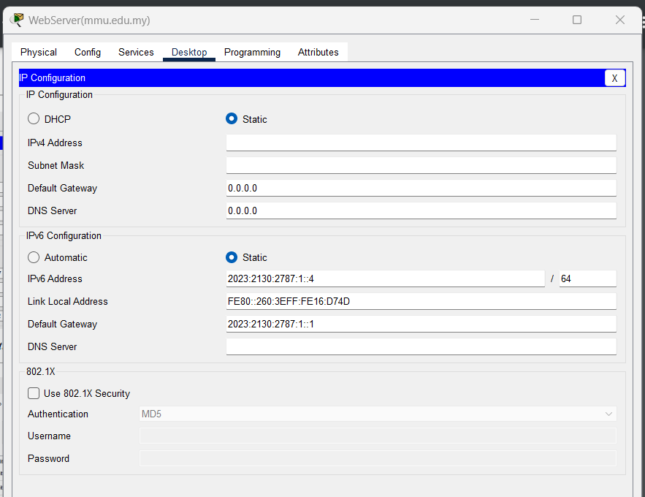
Figure 10.1. IP Configuratin for web server
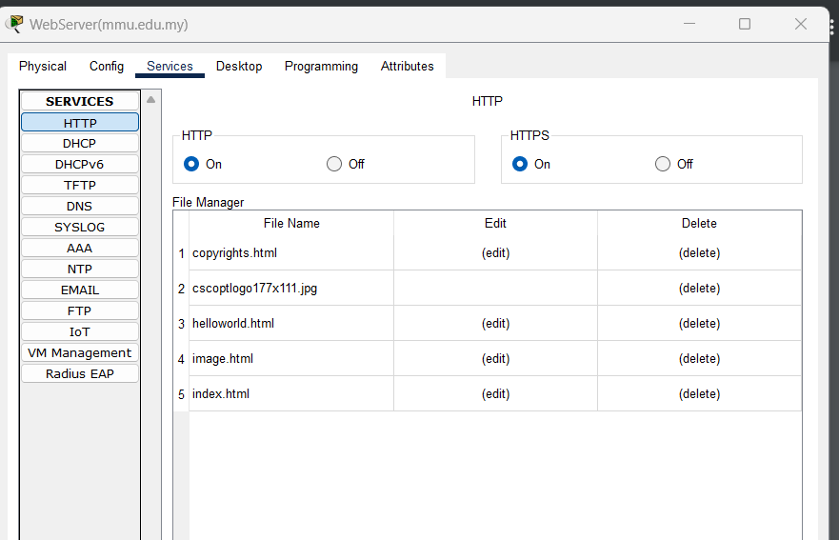
Figure 10.2. HTTP configuration for web server
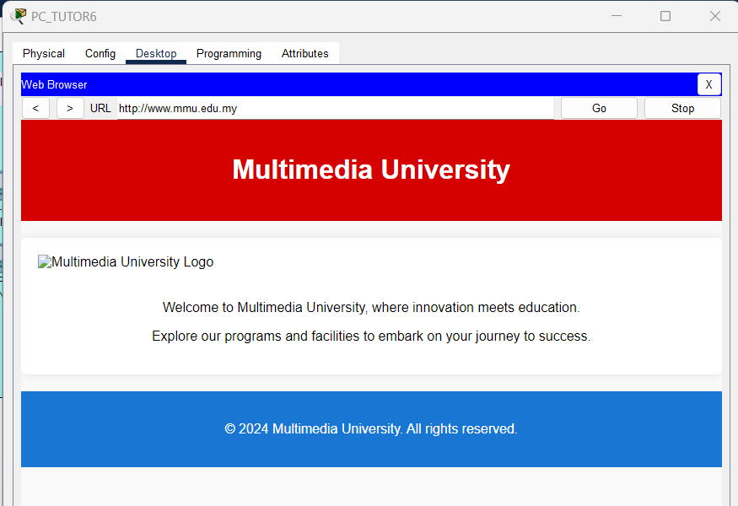
Figure 10.2 Accessing web server from PC6 tutor room

FTP SERVER CONFIGURATION

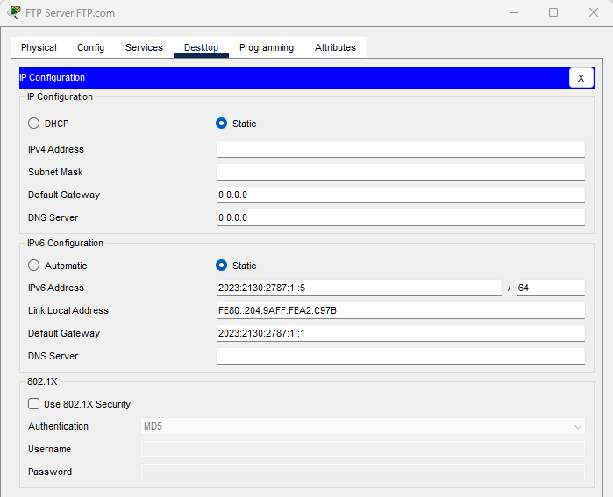
Figure 11.1: IP Configuration of FTP Server

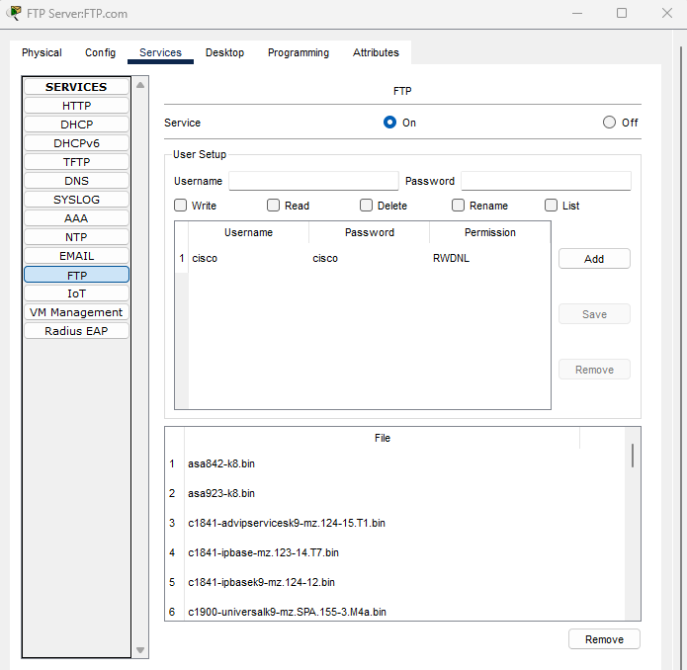
Figure 11.2. FTP Service Configuration
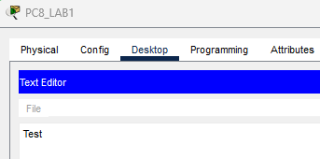

Figure 11.3 : Creating a test file using PC8_Lab1
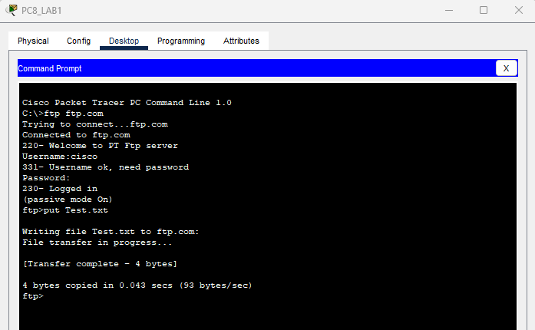
Figure 11.4 : Uploading test file named Test.txt to the File Server from PC8_LAB1
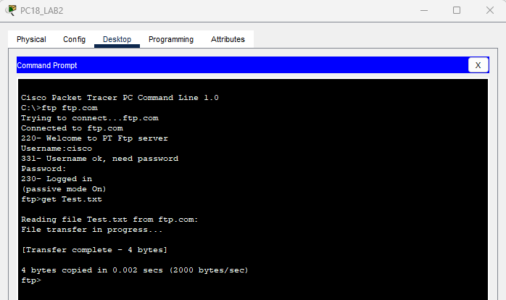
Figure 11.5 : Downloading Test.txt file to PC18_lab2
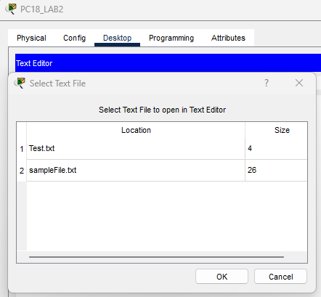

Figure 11.6 : Test.txt file is downloaded to PC18_LAB2
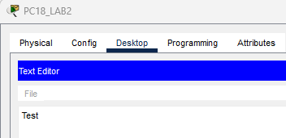

Figure 11.7 : Contents of Test.txt file can be opened and read using PC18_LAB2

DNS SERVER CONFIGURATION

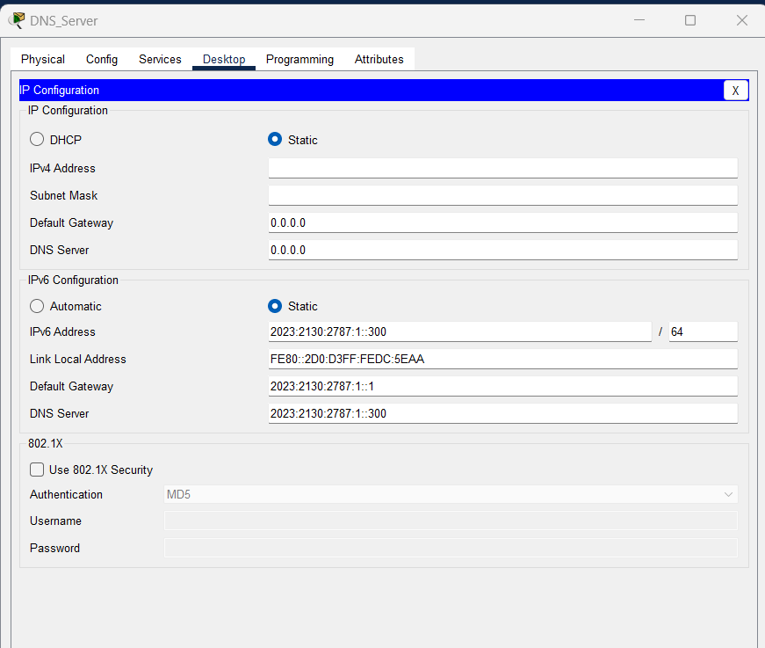
Figure 12.1. IP configuration for DNS server
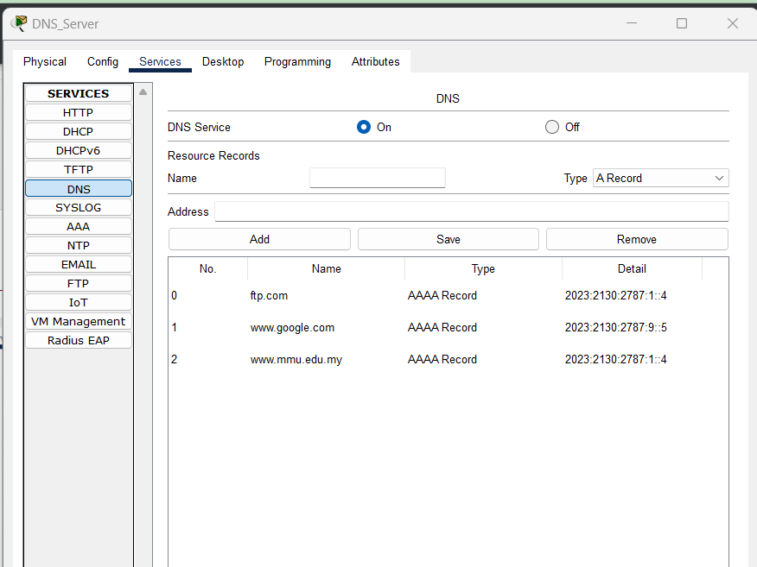
Figure 12.2. DNS services configuraion for DNS Server

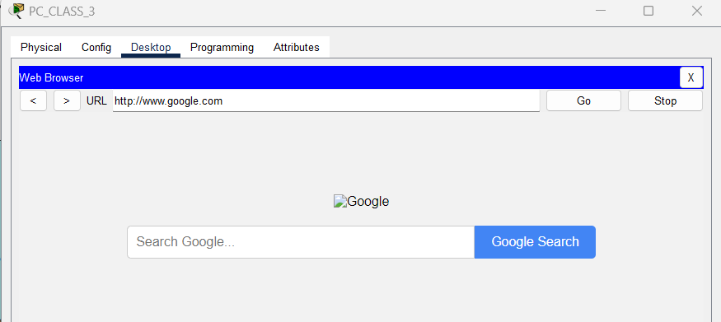
Figure 12.3 Accessing DNS server from PC3 classroom

TM SERVER CONFIGURATION
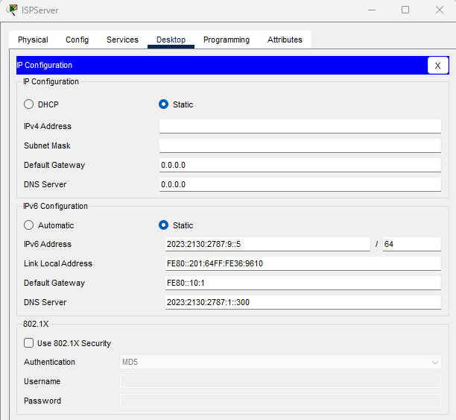
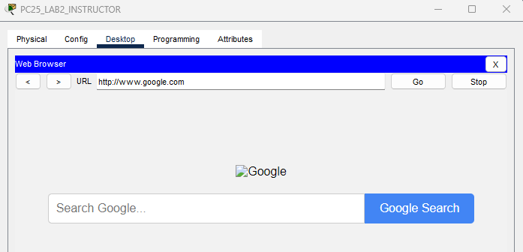
Figure 13.1 : IP Configuration of TM Server(ISP Server)
Figure 13.2 : PC25_LAB2_INSTRUCTOR can access www.google.com

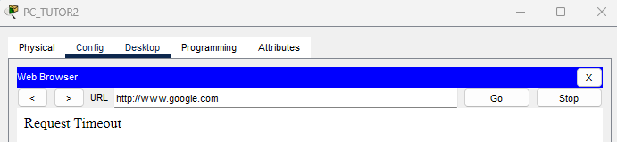
Figure 13.3 : PC_TUTOR2 not allowed access to www.google.com

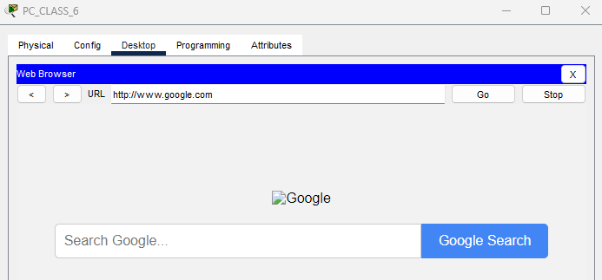
Figure 13.4 : PC_CLASS_6 allowed access to www.google.com
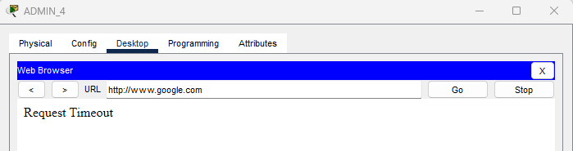
Figure 13.5 : ADMIN_4 not allowed access to www.google.com

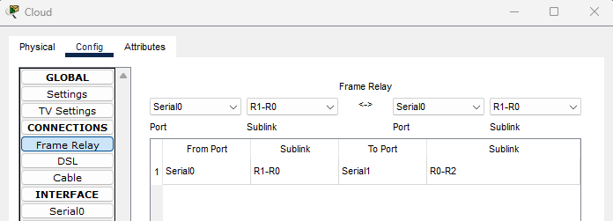
Figure 13.6 : Shows the link between Serial0 and Serial1 in Frame Relay
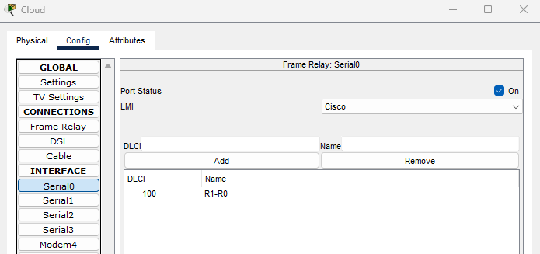
Figure 13.7 : Shows interface for Serial1
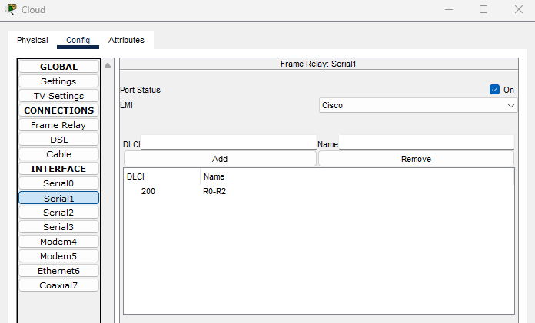
Figure 13.8: Shows interface for Serial1

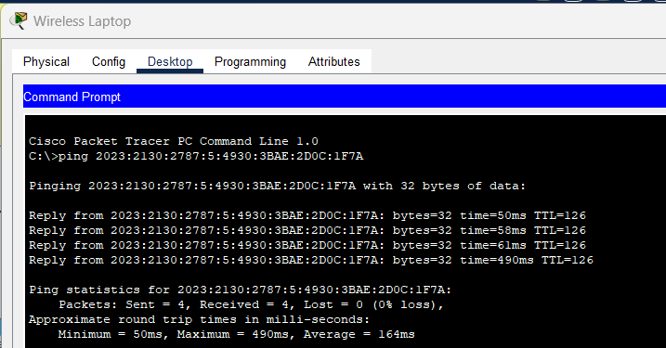
CONNECTIVITY STATUS

Figure 14.1. Ping from wireless laptop to LAb2_PC22
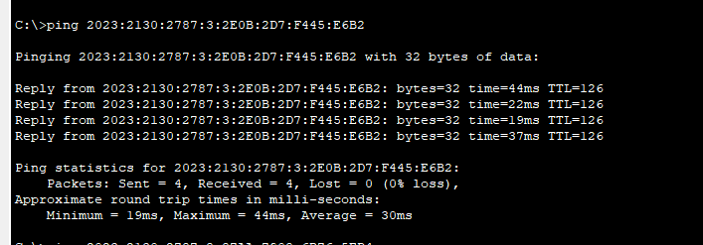
Figure 14.2 ping from wireless laptop to LAB1_PC22
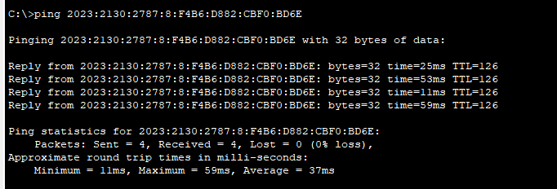
Figure 14.3 Ping from wireless laptop to ADMIN_2
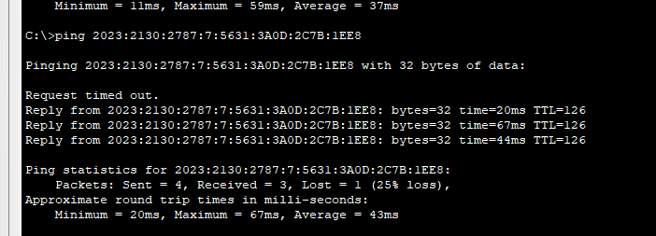
Figure 14.4. Ping from wireless laptop to Sysadmin (management)
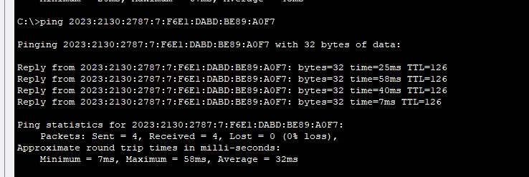
Figure 14.5. Ping wireless laptop to classroom PC4

